**TS8111 USB Disk Upgrade Instructions**

**Version: V3.9**

Filename: **TS8111.zip** (unzip “TS8111 20220608 VER39_39_10_22_21_30.rar”)

Release Date: **6/08/2022**

|  |  |
| --- | --- |
| Release Notes: | |
| 1 | Optimization the audio out of sync. |

## How to upgrade by USB Disc

Requirements:

* TCL Sound Bar
* Computer connected to the Internet
* A USB flash device formatted in FAT/FAT32 with at least 100MB of free space.
  + Remove all files and folders from the USB flash device (it should be empty).

Upgrade Procedure:

1. Unzip "TS8111 2020XXXX VERXX_XX_XX_XX_XX_XX", move or copy the upgrade file **TS8111.zip** inside the root directory of the USB flash device.
2. Disconnect all cables from your TCL Sound Bar, excluding the power cord.
3. Power On your TCL Sound Bar.  Using the sound Bar button or the TCL Sound Bar remote, select any source input.
4. Insert the USB flash device, and the TCL Sound Bar will automatically detect the file and enter the upgrade mode

* The LED display will show **“UPG”** during the software upgrade process.
* IMPORTANT:  During the update process, DO NOT remove the USB storage device, unplug the power cord or turn off the Sound Bar.

1. Once the software update is completed, the TCL Sound Bar will automatically enter the standby mode - as shown in the image below.

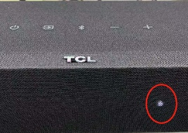

1. Plug out the USB flash device from the Sound Bar to avoid repeated upgrades before you power it on.